prac 1

Aim – Draw symbol and circuit diagram of all logic gates and verify its truth table.

1.] not gate-

Symbol- 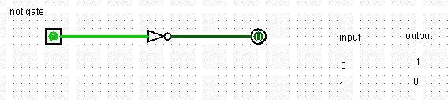

Circuit diagram- 

Hence – the truth table of NOT gate is verified.

2.]or gate-

Symobl -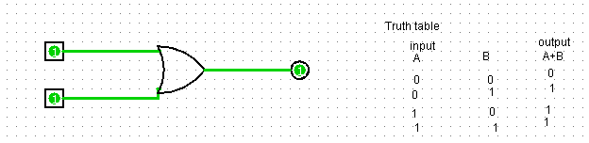

Circuit diagram- 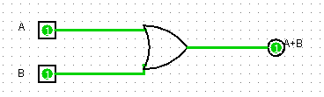

Hence – the truth table of OR gate is verified.

3.] AND gate-

Symbol - 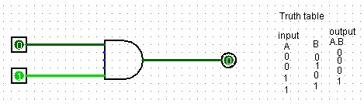

Circuit diagram - 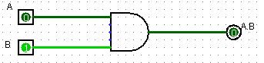

Hence- The truth table of AND gate is verified.

4.]NOR gate-

Symbol- 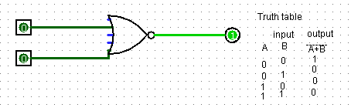

Circuit diagram - 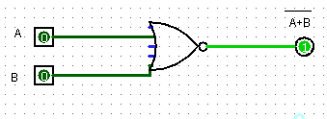

Hence – The truth table of NOR Gate is verified.

5.]NAND gate –

Symbol- 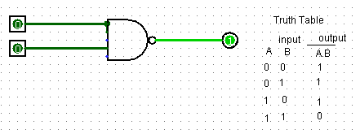

Circuit diagram-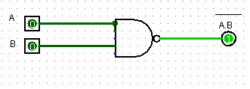

6.] XOR gate-

Symbol- 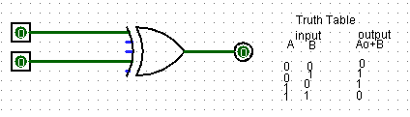

Circuit diagram-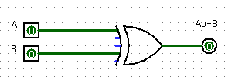

7.] XNOR gate-

Symobol-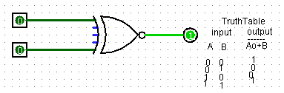

Circuit diagram- 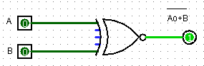

Hence – The Truth table of EXNOR Gate is Verified.